The Big Switch Off 2009 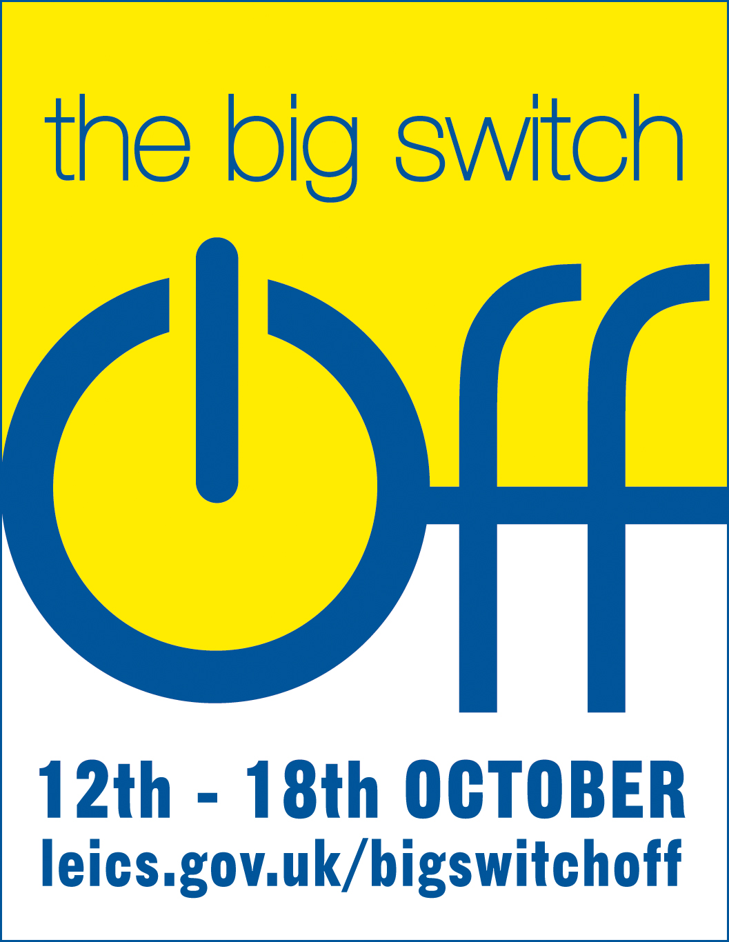
This is to certify that

(Name of volunteer/organisation)

Took part in the Big Switch Off campaign to save energy, money and the environment

