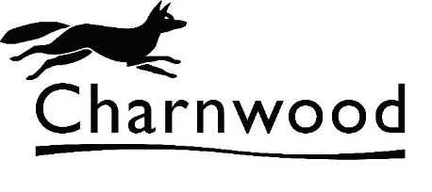**COUNCIL TAX**

**DISCOUNT FORM – SOLE OCCUPANCY**

Charnwood B. C.  - Council Tax, Southfield Road,

Loughborough, Leicestershire, LE11 2TX

TEL : 01509 634666

E-MAIL : council.tax@charnwood.gov.uk

|  |  |  |  |  |
| --- | --- | --- | --- | --- |
|  | Account No: | Property Reference: | Date: | |
|  |  |  | 04/06/2010 |  |
|  |

This form constitutes an application under Regulation 14 of the Council Tax (Administration & Enforcement) Regulations 1992 (SI 1992 No. 613).

**Please read the declaration below then complete and sign the form, if appropriate, and return it to Charnwood Borough Council,** Council Tax, Southfield Road, Loughborough, Leicestershire, LE11 2TX**.** If your application is successful, a new bill will be issued to you. In the meantime, bills previously issued must be regarded as correct and due for payment as requested.

|  |
| --- |
| **Property Address :** **,** **,** **,** **,** **,** |

**Please list below all residents aged 16 or 17 :**

|  |  |  |  |
| --- | --- | --- | --- |
| **Title** | **Forename(s)** | **Surname** | **Date of Birth** |
|  |  |  |  |
|  |  |  |  |
|  |  |  |  |

|  |  |  |  |  |
| --- | --- | --- | --- | --- |
| **DECLARATION: I certify that I am the only person aged 18 or over resident at the above address and, as such, claim 25% Sole Occupant Discount from Council Tax with effect from (enter effective date) :** | | | | **/ /** |
| **I undertake to advise the Revenues Manager within 21 days should the number of persons resident in the property increase. I understand that it is a criminal offence to receive discount to which I am not entitled and I also understand that it is an offence to give false information. The latter could make me liable for a penalty of £50 for a first offence and £200 for each subsequent offence.** | | | | |
| **Full Name:** |  | **Date:** | |  |
| **Telephone Number:** | **Day:** |  |
| **Signed:** |  |
| **Evening:** |  |