COUNCIL TAX – DISREGARD FORM  RELIGIOUS COMMUNITY |  |  | 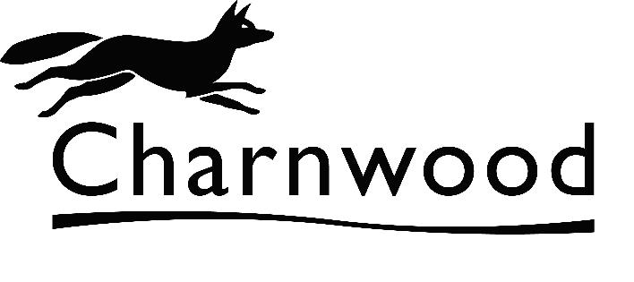
Charnwood Borough Council, Council Tax Dept
Southfield Road, Loughborough, Leicestershire, LE11 2TX
Email: council.tax@charnwood.gov.uk
 |  |  | Account No: | Property Reference: | Date:
 |  |  |  |  | 01/07/2010

Dear ,
Council Tax Account:
Re: , , , ,

This form constitutes an application under Regulation 14 of the Council Tax (Administration & Enforcement) regulations 1992 (SI 1992 No. 613).

Please read the guidance notes overleaf and the declaration below then complete and sign the form, if appropriate, and return it ,together with a letter of confirmation from the head of the religious community of each person to be disregarded to Charnwood Borough Council, Council Tax Dept, Southfield Road, Loughborough, Leicestershire, LE11 2TX.
You have advised that some or all of the residents of the address above are members of a religious community. In this case they may be disregarded for Council Tax Discount purposes and you, the liable person, may be entitled to discount from your Council Tax bill. If the details are verified and discount is awarded, a revised bill will be issued. In the meantime, bills previously issued must be regarded as correct and due for payment as requested.

How many people aged 18 or over (including yourself) live at the above address?
Please give details below of anyone you wish to be considered for disregarded status (continue overleaf if necessary) :
Full Name | Date of conditions  overleaf being met |  | Letter Enclosed?
 |  |  | YES |  | NO
 |  |  | YES |  | NO
 |  |  | YES |  | NO

DECLARATION:
I declare that the information given above is correct to the best of my knowledge. I verify that I am the person responsible for the above property and hereby claim any Council Tax discount available as a result of this application. I undertake to advise the Revenues Manager within 21 days of any change in circumstances affecting my entitlement, or if responsibility for the property passes from me. I understand that it is a criminal offence to receive discount to which I am not entitled and I also understand that it is an offence to give false information. The latter could make me liable for a penalty of £50 for a first offence and £200 for each subsequent offence.
Full Name: |  | Date:
 |  | Telephone Number: | Day:
Signature:
 |  |  | Evening:

COUNCIL TAX DISREGARD GUIDANCE NOTES

MEMBER OF A RELIGIOUS COMMUNITY

The above is defined as a person who:

- is a member of a religious community, the principal occupation of which consists of prayer, contemplation, education, the relief of suffering, or any combination of these; and
- has no income or capital of his/her own (disregarding any income by way of a pension in respect of former employment) and is dependent on the community concerned for his/her material needs.

PLEASE SUPPLY A LETTER FROM THE HEAD OF THE RELIGIOUS COMMUNITY OF THE PERSON(S) TO BE DISREGARDED CONFIRMING THE ABOVE.

Data Protection
For information about how & why we may process your personal data, your data protection rights or how to contact our data protection officer, please view our Privacy Notice www.chanwood.gov.uk/privacynotice.

