03/09/2021

Equality Impact

Assessment

Customer Service Strategy
2022
-
2025

•

Background

An Equality
Impact Assessment is an improvement tool. It will assist you in ensuring that you have
thought about the needs and impacts of your service/policy/function in relation to the protected
characteristics. It enables a systematic approach to identifying and re
cording gaps and actions.

•

Legislation
-

Equality Duty

As a local authority that provides services to the public, Charnwood Borough Council has a legal
responsibility to ensure that we can demonstrate having paid due regard to the need to

✓

Eliminate discrim
ination, harassment, victimisation.

✓

Advance Equality of Opportunity

✓

Foster good relations

For the following protected characteristics:

✓

Age

✓

Disability

✓

Gender reassignment

✓

Marriage and civil partnership

✓

Pregnancy and maternity

✓

Race

✓

Religion
or

belief

✓

Sex
(
Gender
)

✓

Sexual orientation

What is prohibited?

✓

Direct Discrimination

✓

Indirect Discrimination

✓

Harassment

✓

Victimisation

✓

Discrimination by association

✓

Discrimination by perception

✓

Pregnancy and maternity discrimination

✓

Discrimination arising from disabili
ty

✓

Failing to make reasonable adjustments

Complete this action plan as you go through the questions

•

Step 1
–

Introductory information

Title of the policy

Customer Service Strategy 2022
-
2025

Lead officer and others
undertaking this assessment

Karey Barnshaw

Date EIA started

23
^{rd}

August 2021

Date EIA completed

24
^{th}

August 2021

- Step 2 – Overview of policy/function being assessed
Outline: What is the purpose of this policy? (Specify aims and objectives)

Charnwood Borough Council is transforming the way that it interacts with its customers. This strategy provides the vision and principles for this transformation and in doing so, outlines our ambition and appetite to meet our customers’ needs.
This strategy sets out our vision to achieve the best possible experience for our customer, whoever they are (residents, businesses, partners, or suppliers) and whenever they deal with us.
What specific group/s is the policy designed to affect/impact and what is the intended change or outcome for them?
The Strategy could impact on all customers who contact the Council. The aim of the strategy is to place our customers at the heart of everything we do, to make every interaction a positive experience: accessible, consistent, efficient, and simple.
Which groups have been consulted as part the of creation or review of the policy?

Previous residents surveys, a digital skills gap analysis and customer insight data has all been used to inform the strategy. In addition, customer comments/feedback, contact data and statistics have also been utilised. No specific groups have been consulted on as part of the development of the strategy.
- Step 3 – What we already know and where there are gaps
List any existing information/data do you have/monitor about different diverse groups in relation to this policy? Such as in relation to age, disability, gender reassignment, marriage and civil partnership, pregnancy & maternity, race, religion or belief, sex, sexual orientation etc. Data/information such as:
- Consultation
- Previous Equality Impact Assessments
- Demographic information
- Anecdotal and other evidence
Digital Skills Gap Analysis report completed by Citizen Online which identifies digital skills gaps by age and location
All other data and information are not specific to the groups listed
Previous outcomes in Resident Survey’s (specify year if known)
Census Data (has this been used during the process, if so, I would reference it here)
What does this information / data tell you about diverse group? If you do not hold or have access to any data/information on diverse groups, what do you need to begin collating / monitoring? (Please list)
The digital skills gap analysis provides a breakdown by age groups and locations where there is likely to be a higher risk of digital exclusion. This information has been used to create an action plan to address the high-risk areas and recommendations from the report.

- Step 4 – Do we need to seek the views of others? If so, who?

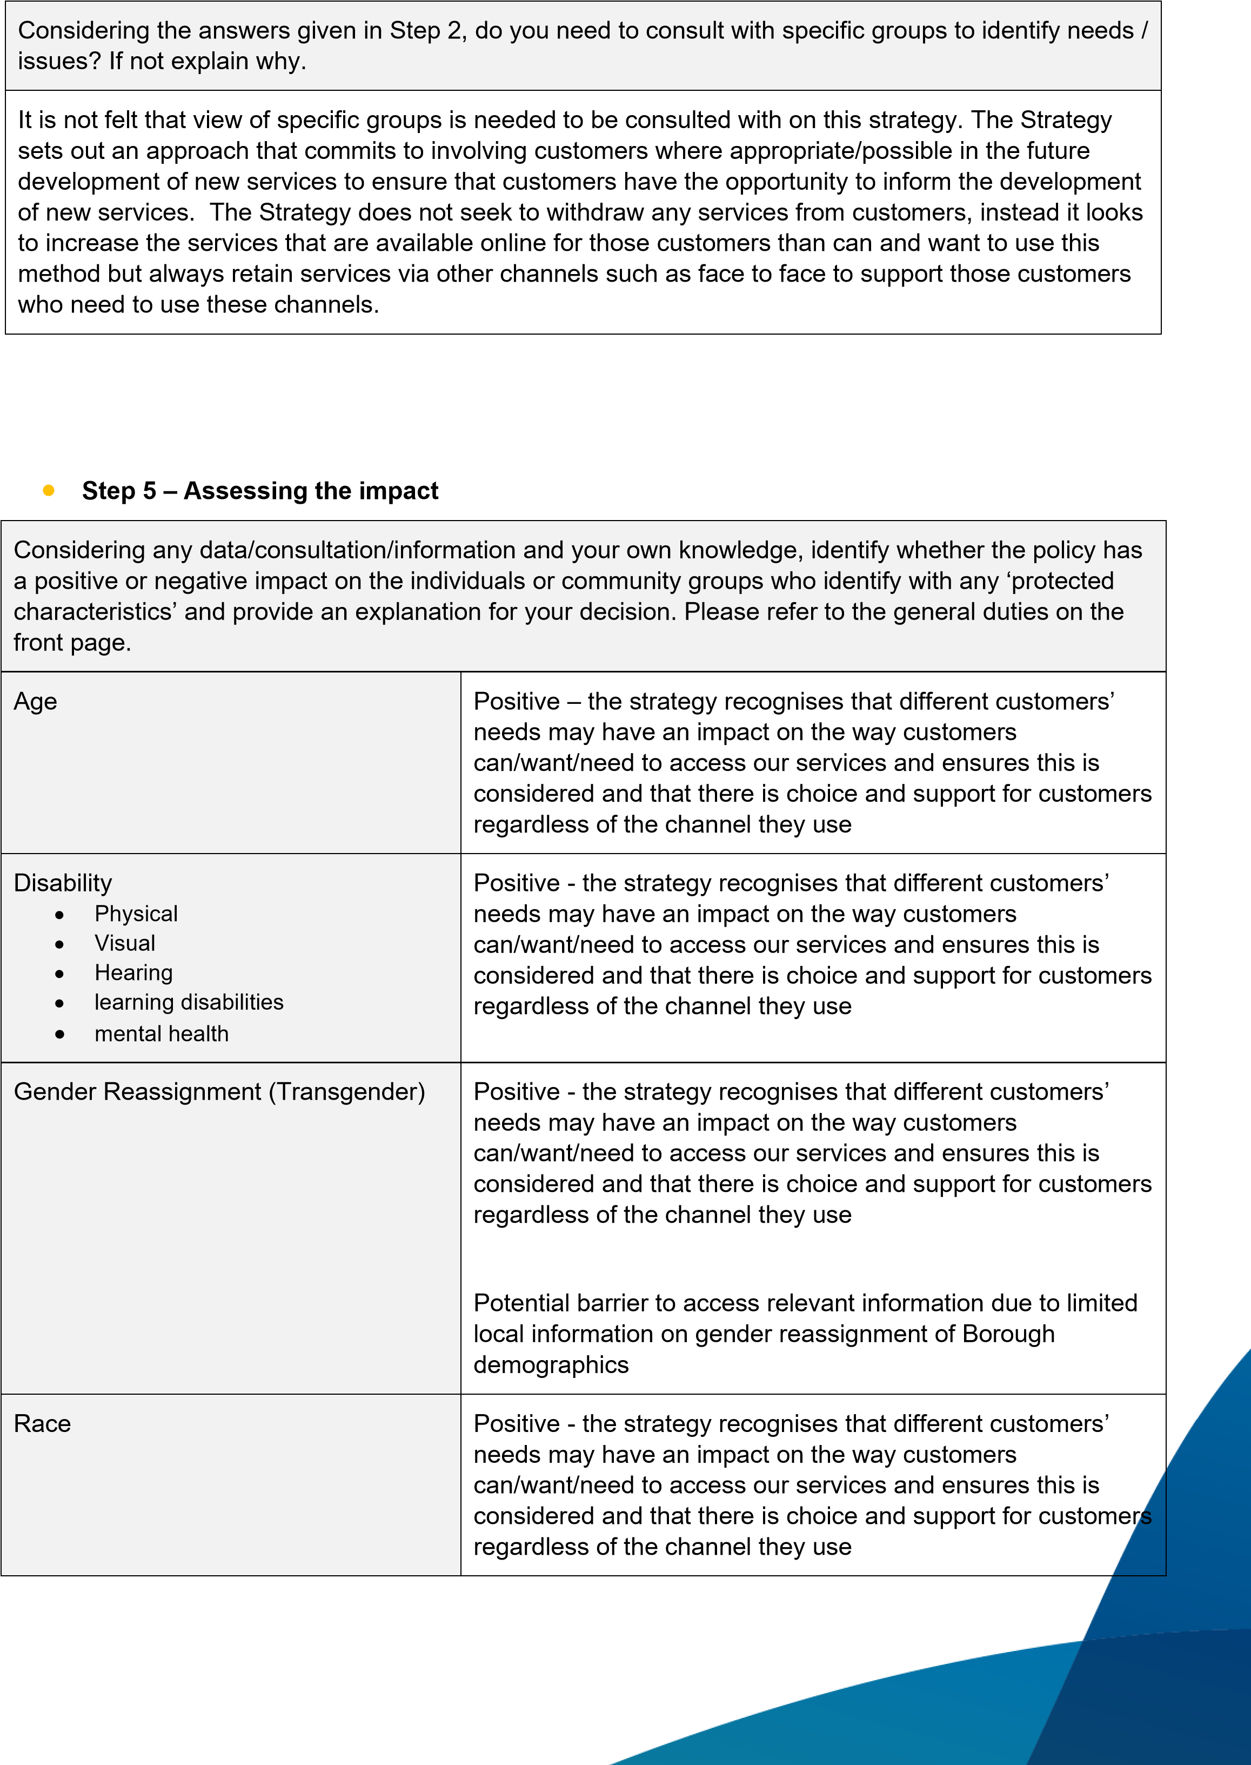

 | Language may constitute a barrier however the strategy will be available in different languages as required
Religion or Belief (Includes no belief) | Positive - the strategy recognises that different customers’ needs may have an impact on the way customers can/want/need to access our services and ensures this is considered and that there is choice and support for customers regardless of the channel they use
Sex (Gender) | Positive - the strategy recognises that different customers’ needs may have an impact on the way customers can/want/need to access our services and ensures this is considered and that there is choice and support for customers regardless of the channel they use  Potential barrier to access relevant information due to limited local information on sexual orientation of Borough demographics
Sexual Orientation | Positive - the strategy recognises that different customers’ needs may have an impact on the way customers can/want/need to access our services and ensures this is considered and that there is choice and support for customers regardless of the channel they use
Other protected groups  - Pregnancy & maternity  - Marriage & civil partnership | Positive - the strategy recognises that different customers’ needs may have an impact on the way customers can/want/need to access our services and ensures this is considered and that there is choice and support for customers regardless of the channel they use
Other socially excluded groups  - Carers  - Low literacy  - Priority neighbourhoods  - Health inequalities  - Rural isolation  - Asylum seeker and refugee communities | Positive - the strategy recognises that different customers’ needs may have an impact on the way customers can/want/need to access our services and ensures this is considered and that there is choice and support for customers regardless of the channel they use

Where there are potential barriers, negative impacts identified and/ or barriers or impacts are unknown, please outline how you propose to minimise all negative impact or discrimination.
- If you have identified adverse impact or discrimination that is illegal, you are required to take action to remedy this immediately.
- Additionally, if you have identified adverse impact that is justifiable or legitimate, you will need to consider what actions can be taken to mitigate its effect on those groups of people.
The strategy recognises that different customers’ needs may have an impact on the way they can/want/need to access our services and ensures this is considered to minimise any negative impact by providing choice and support for customers regardless of the access channel they use.
Effective monitoring of all protected characteristics will be vital to ensure any potential barriers are removed at the earliest opportunity.
