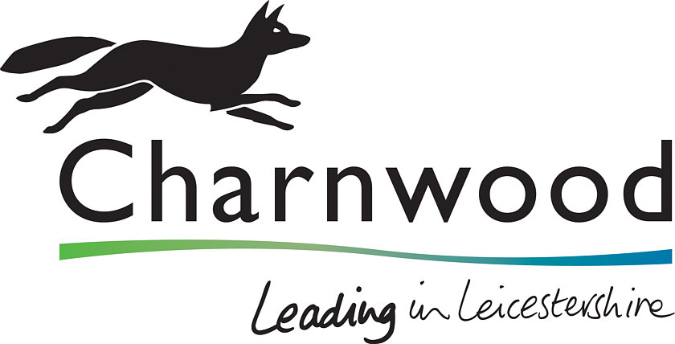

Charnwood Borough Council

EEM COMMUNITY DONATIONS FUND
POLICY

 | DATE:  REVIEW DATE: | June 2024  June 2027

Approved by the Charnwood Housing Residents Forum June 2024

CONTENTS

Section | Page
- What is the EEM community donation fund? | 3
- Criteria for the fund | 3
- Support for projects | 4
- Who can apply? | 4
- How to apply? | 4
- Underspends | 5
Appendix 1 – Application form

What is the EEM community donation fund?

  - EEM is a national procurement framework organisation. When procuring various contracts Landlord Services can use framework organisations as an alternative to open tenders. As part of the social value aspect of using the framework EEM donates a share of its profits to organisations using their framework.

  - The funds are donated around September each year. As it is based on EEM’s profits and the value of contracts Landlord Services have procured through them, the amount received can differ each year.

  - EEM donates the funds to support community projects which would not normally be funded through Landlord Services’ own budgets.

  - As the amount donated cannot be guaranteed, grants cannot be given for continuing running costs for a project or community group. There are no limits, however, to the number of times groups can apply for grants. The funding must support a group or project that will improve the communities where they live. The project should not benefit just one individual.

  - Decisions on which projects will be funded are decided by ballot through the Charnwood Housing Residents’ Forum (CHRF) at a meeting following when the funds are received, and applications are submitted. A record will be kept each year to ensure that monies are distributed fairly across groups and projects throughout the borough.

  - CBC staff will provide advice, information to the CHRF in assessing and approving the applications. CBC will also identify projects and it will actively seek nominations where projects will radically improve communities.

  - Applications can be received from any group or project working to improve communities throughout the borough.

Qualifying criteria for the EEM community donation fund

  - To qualify a bid has to be:

- something that will benefit a community and not an individual;

- something that will have long term benefits for a community;

- something that has the support of the majority of the community. Bidders must evidence this support and consultations with the community as part of their application;

- something that has no ongoing costs for Charnwood BC;

- something Charnwood BC Landlord Services would not normally fund;

- fully-financed: where a project is anticipated to cost more than the grant, evidence will be required to demonstrate from where the rest of funding will be raised.

2.2 In accepting the grant bidders must consent to their project being promoted by both Charnwood BC and EEM.

  - The project:

- can be environmental to open spaces or to improve existing areas;

- can help prevent or reduce anti-social behaviour;

- can be for activities or projects which promote health and well-being;

- should enhance the quality of life for the community;

- can be a refurbishment of an existing community facility;

- cannot be for projects which would normally be funded out of alternative budgets e.g. planned maintenance, grounds maintenance;

  - Where the funding bids exceed the amount of budget available in any financial year, the following criterion will be applied:
- Projects/groups where grants were awarded in the previous year will not be considered in the current year.

Support for projects

Applicants will need to demonstrate either that there is a clear need for a project or that the community have been consulted and there is support for the proposal. The evidence of this support/need will depend on the nature of the project being proposed. The customer engagement team will look at evidence to ensure there is sufficient support/need for the project.

Who can apply?

  - Community organisations, residents’ groups or community interest groups can apply.

  - Each year CBC will actively seek nominations for the bids from community groups, council departments and other agencies working with communities and suggestions from local councillors.

  - The grant will be promoted through the Council’s social media and Your Homes Matter tenant magazine.

How do I apply?

  - Any community organisation or group can submit an application by completing an application form in writing or online. If you require assistance to complete the form then please contact a member of the customer engagement team on 01509 634955, by email involvement@charnwood.gov.uk or by writing to Charnwood Borough Council, Southfield Road. Loughborough LE11 2TN.

  - Submissions can be received by CBC’s customer engagement team anytime throughout the year. Applications received prior to the funding being received from EEM will be logged and will be taken to the CHRF meeting following the funds being received from EEM. If there are any funds underspent any new submissions will be taken to the next CHRF meeting following its receipt until the budget has been fully spent.

  - Each project application should include:

- what the project is;

- who will benefit from the project;

- why it is needed and any evidence to support it;

- what the benefits will be to the community;

- what evidence is there to demonstrate that the project has a local need or support.

Stage 1

  - Completed applications are received by the customer engagement team who assess the application to ensure that it meets the required criteria for a bid and there is evidence of support/need.

  - Where there is any uncertainty as to whether the application meets the criteria, EEM will be contacted to ensure the project meets their objectives. If required, the customer engagement team will request further information regarding the project.

  - The customer engagement team will send a letter to the group/organisation acknowledging receipt of the application and confirming within ten days whether or not it meets the criteria.

Stage 2

  - Voting on the bids will take place at the CHRF meeting following receipt of the funds from EEM.. Projects must receive support from at least 50% of tenants voting at the meeting.

  - The customer engagement team will administer the vote and inform the organisations/groups of the successful applications. EEM will be notified of the successful projects.

Stage 3

  - Once a project has started or completed the group/organisation must contact the customer engagement team so that suitable media coverage can be issued.

  - Successful projects will be shown in Your Homes Matter and through the council’s media channels and EEM may also promote the project through its media.

  - After each project has been completed, a feedback survey will be sent to organisation/groups to understand if the project has fulfilled its objectives. The group/organisations will also be given an opportunity to feedback on the grant funding process.

6. Underspends

6.1 There may be occasions where there are not enough viable projects submitted by date of the CHRF voting meeting to allocate all the budget at the voting stage of the process [5.7].. Priority will be given to date order submissions are received.

6.2 If there are still funds remaining after the October meeting the customer engagement team will undertake additional promotional work to source community projects requiring funding.

6.3 Where there is any underspend where all projects have been agreed at the voting stage [5.7] then any submissions received after the meeting following receipt of the funds from EEM will be considered and stages 1 – 3 of the process will be carried out with voting taking place at the CHRF meeting following receipt of the submission until all the funds have been spent.

Appendix 1 – Application Form

EEM Community Donation application form

1. Name of residents’ group/organisation submitting the bid:
:

2. Contact name and address for correspondence:

3. Telephone number:

Email address:

4. Briefly describe the proposal, (where possible include measurements,
photographs, and drawings)

(continue on another sheet if necessary)
5. Describe the reasons for the proposal and explain how it will benefit
residents in the area.
(Things you might want to consider are how it improves the overall appearance of the area, who will benefit from the project, and what opportunities are generated for community involvement.)

(continue on another sheet if necessary)
6. Please provide evidence of support and/or need for this project

7. Please indicate if the project meets any of the following criteria:
(Please tick all those that apply)

Help prevent or reduce anti-social behaviour 

Contribute to an environmental improvement to communal areas 

Encourage activities to engage with the community 

Enhance the quality of life for communities, including health and well being 

8. Please tell us how your project meets the criteria:

9. What is the break down and total cost of your project?

What is the amount you are requesting for in this grant application?

If this is less than the total cost of the project how will the remainder be funded?

In signing this application, you are agreeing that all information
is true and accurate and that the organisation will agree to media publicity
Signed:

Position in organisation:

Date:

Please return the completed form to:

Customer Engagement Team, Charnwood Borough Council, Council Offices, Southfield Road, Loughborough, LE11 2TX.

For all enquiries, assistance completing this application form please contact the Customer Engagement Team on 01509 634955 or email involvement@charnwood.gov.uk.

Version control

Created / Amended by | Date reviewed | Detail of amendment | Version
Created by Sally Ramalho, Principal Officer – Customer Engagement & Older Person’s Services | April 2021 |  | 1

